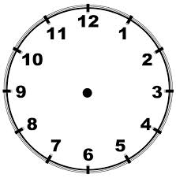
45 mín

45 mín

55 mín

50 mín

40 mín

20 mín
mín

15 mín

5 mín

60 mín

35 mín

25 mín

10 mín

30 mín
40 mín

Nafn_______________________________________
35 mín

25 mín

30 mín

Nafn_______________________________________

60 mín

55 mín

5 mín

50 mín

10 mín

20 mín
mín

15 mín

