Stærðfræði

Samlagning
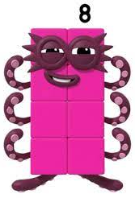
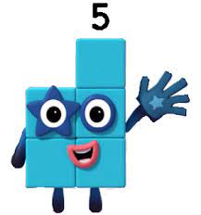

Fúsi Plús

Nafn _________________________

Hjálpaðu Fúsa plús

+ = ________

+ = _______

+ = ______

1 + 1 = ______

+ + = ______

+ + = ______

+ + =______

1 + 1 + 1 = _______

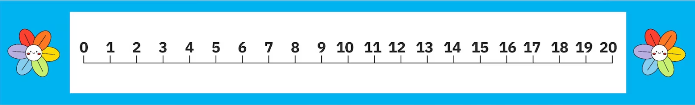
0 __________________________________
1 __________________________________
2 __________________________________
3 __________________________________

+
= ______

+ + = ______

+ + = ______

+ + + = ______
+ + + = ______

+ + + = ______
+ = ______
+ = ______

+ = ______

2 + 2 = ______
1+1+1+1= ______
+ = ______
+ = ______

+ = ______

1 + 2 = ______ 2 + 1 = ______
2 + 2=
1 + 2 =
+ = ______
+ = ______
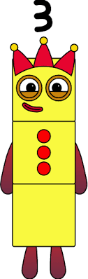
+ = _____

1+1+1+1= ______
1 + 3 = ______ 3 + 1 = ______
1 + 3
4 __________________________________
+ = ______
+ = ______

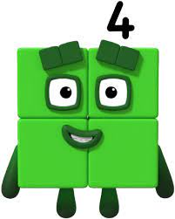
+ = ______

1+1+1+1+1= ______

1 + 4 = ______ 4 + 1 = ______
1 + 4
5 __________________________________
+ = ______
+ = ______

+ = ______

1+1+1+1+1+1= ______
1+ 5 = ______ 5 + 1 = ______
1 + 6
6 __________________________________
+ = ______
+ = ______
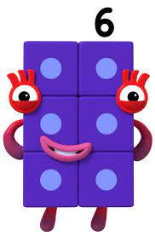
+ = ______

1+1+1+1+1+1+1= ______
1+ 6 = ______ 6+ 1 = ______
1 + 6
7 __________________________________
+ = ______
+ = ______
+ = ______

1+1+1+1+1+1+1+1= ______
1+ 7 = ______ 7 + 1 = ______
1 + 7
8 __________________________________
+ = ______
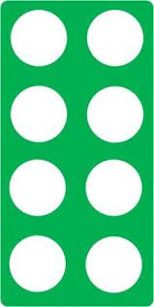
+ = ______
+ = ______

1+1+1+1+1+1+1+1+1= ______
1+ 8 = ______ 8 + 1 = ______
1 + 8
9 __________________________________
+ = ______
+ = ______

+ = ______

1+1+1+1+1+1+1+1+1+1= ______
1+ 9 = ______ 9 + 1 = ______
1 + 9
10 _________________________________
+ = ______

+ = ______
+ = ______
3 + 3= ______
1+ 2 = ______ 2 + 1 = ______
3 + 3
6 __________________________________
+ = ______

+ = ______
+ = ______

4 + 4 = ______
+ + + = ______

4 + 4
8 __________________________________
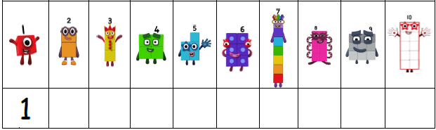
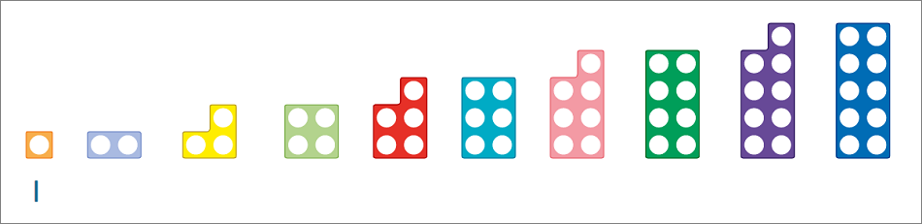
Skrifaðu tölurnar sem vantar

+ = ______
+ = ______
 | 1 |  | 9
 | 5 |  | 7
 | 8 |  | 10
 | 3 | 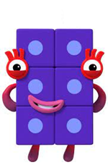 | 2
 | 6 |  | 4
 | 9 |  | 6
 | 4 | 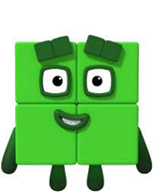 | 7
 | 7 |  | 9
 | 1 |  | 4
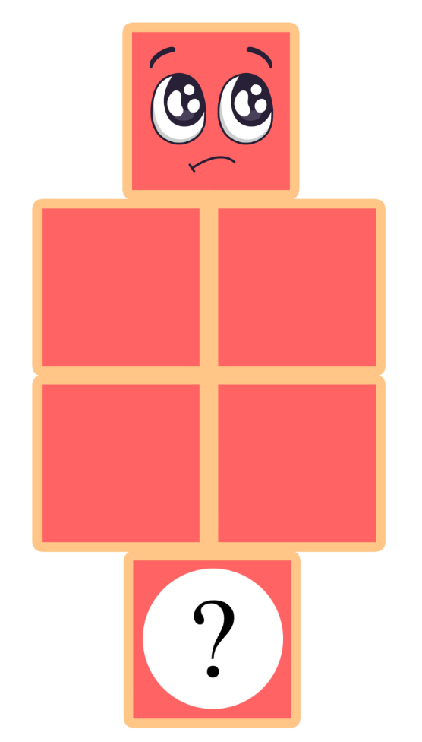
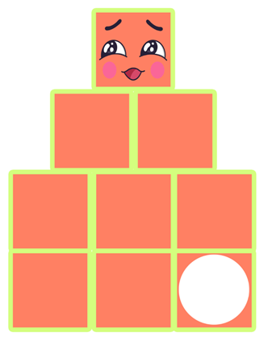
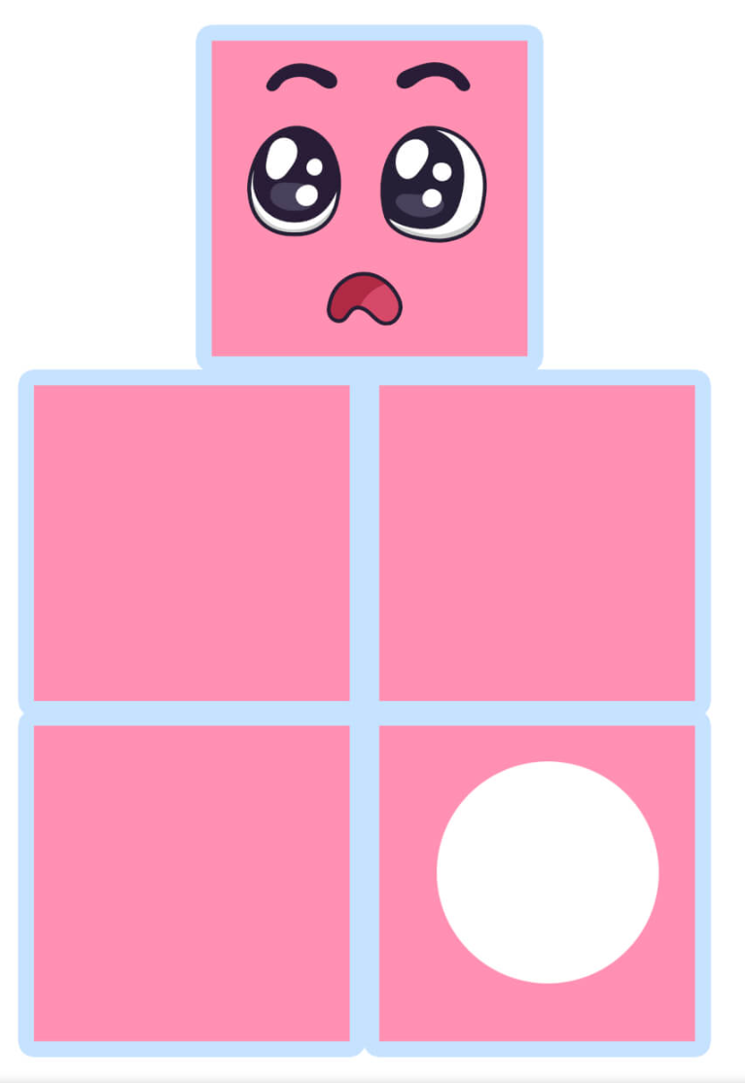
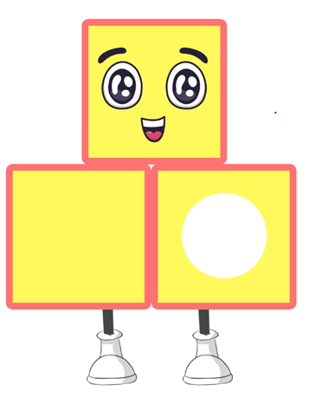
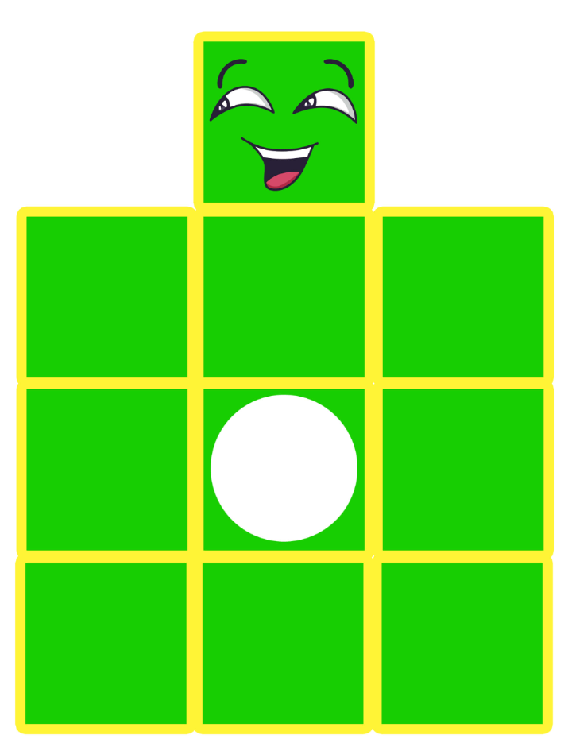
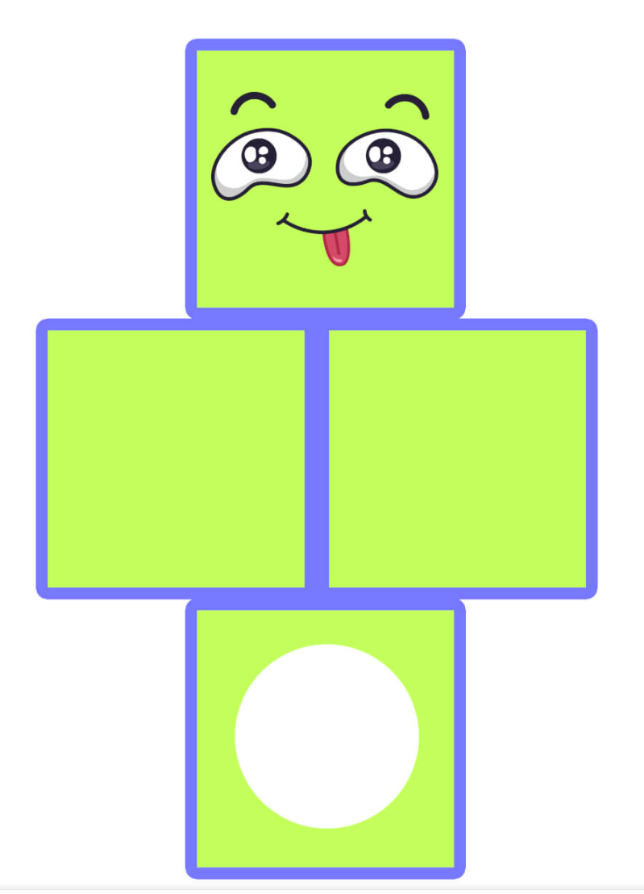
Hvað eru kubbarnir margir?
 | 8 |  | 9
 | 6 |  | 5
 | 1 |  | 10

